Hospice UK online discussion groups: guidance for members

Welcome to Hospice UK’s online discussion groups.

Our online discussion groups aim to connect you with your peers, so you can get support and share ideas and experiences. They are a place where you can continue discussions that started in a network meeting or conference session, ask professionals across the country for practical advice and find solutions to the challenges facing you in your work.
We use Microsoft Teams as the platform for our groups. If your organisation does not have MS Teams, you should still be able to access our online discussions as a guest, via a web browser.

Joining a group

You will be sent a link for each of the online discussion groups you have registered for.
When you click on the link, it will take you to MS Teams (either in a web browser or on your desktop app).
You will be joining the groups as a ‘Guest’ of Hospice UK (because you do not have a Hospice UK email address). This means you will not see our discussion groups listed as one of the Teams channels in your feed.
To see the conversation, you need to click on the Profile icon in the top right corner of the screen (it will either be a circle with your initials in it, or your profile picture).
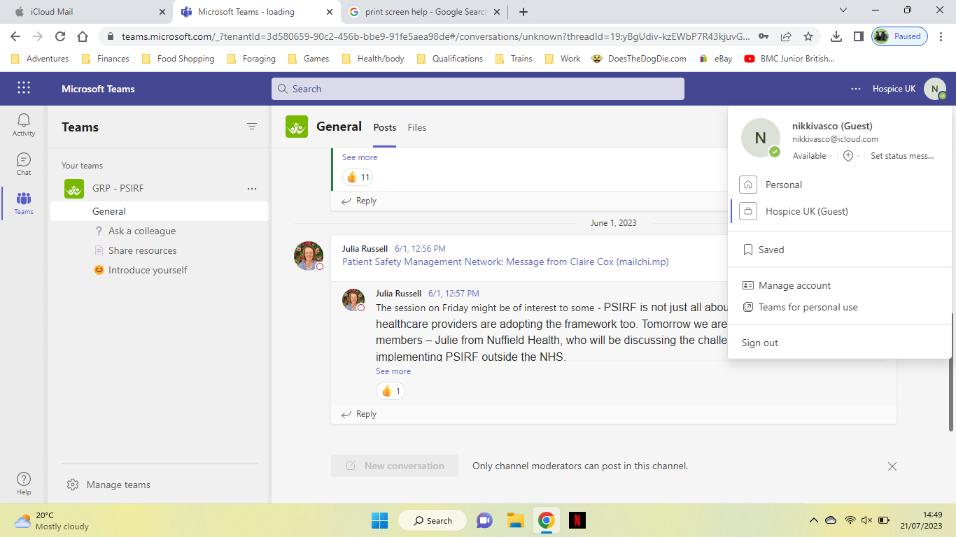
Underneath your profile picture, it says Hospice UK (Guest).
Click on this link to view our online discussion.
You will need to do this every time you want to use our online discussion groups.

Viewing from a mobile device uses the same principle – tap on your profile and you should see the option to view the Hospice UK (Guest) channel.

Notifications

Because you are a Guest, you need to make sure you will be alerted when people post to the Hospice UK channels.
To do this, click on the three dots in the top right corner.

Then click on ‘Settings’…
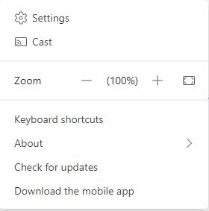

And ‘Notifications’…
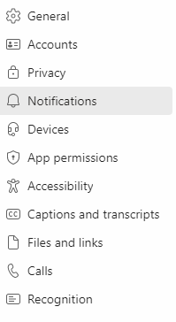
Make sure you are receiving Missed activity emails (you can click on the drop-down arrow to choose how often you get these).
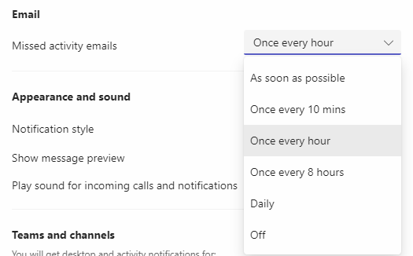

Troubleshooting

If you are not receiving notifications about posts to the group, please check your notification settings (see above).
You should also check to make sure that notification emails are not being sent to your spam/junk mail folders, or being filtered out by your server.
If you are experiencing other problems, please contact innovationhub@hospiceuk.org and we will do our best to help you.

